How to limit the computers in LAN to access the internet through MAC Filter
Product line: wireless question category: function config
Q：Why we need to set the MAC address Filter?
A：Sometimes we want to limit some computers in LAN to access the Internet, you can achieve this through MAC Address Filter.

The steps are followings:
1.You should know the MAC address of the computers which you want to limit to access the Internet. You can check them on the computers with command prompt. Click Start→Run. Type cmd and press Enter.
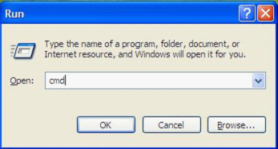

Type ipconfig /all at the prompt window, press Enter, it will show the MAC address and other address information of this computer.
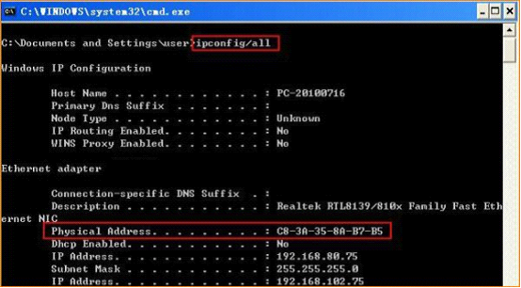

2. Login to the management page of the router.
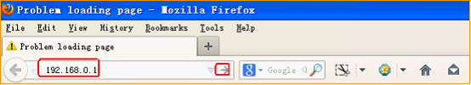

3. Input login password admin(default), to login, then click Advanced
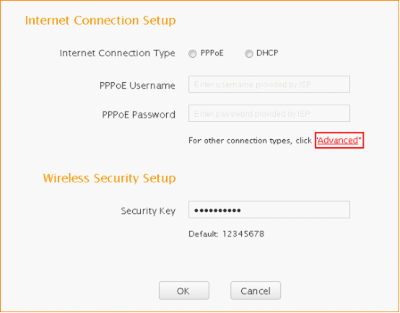
4. Click on security, then click on MAC Filter Settings
For example, if we want to forbid the computer with the MAC address 88:68:5E:15:BF:67 to access the Internet . We can do the settings as the following picture.
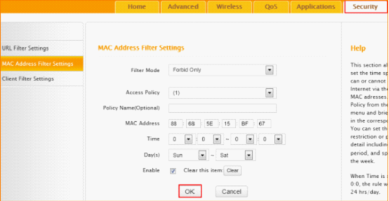

If we only allow the computers with MAC Address 36:4F:79:63:18:8E to access internet, while other computers can’t access internet, we can do the settings as the following picture.
